**SpaceX Falcon 9**

With the primary goal of mars colonization, Elon Musk founded the private spaceflight company SpaceX in 2002. Since then, improvements in both the physical rockets and the software that controls them has allowed SpaceX to become a well known company and has brought it closer to its primary goal. While it isn’t quite ready for interplanetary travel, the company’s current rocket, the Falcon 9, is capable of resupplying the International Space Station and putting satellites into low earth and geosynchronous orbit Geosynchronous orbit is the most useful for satellites and is when the satellite is at the height at which the satellite orbits the Earth at the same rate as the Earth rotates which results in the satellite maintaining the same position above Earth. The Falcon 9 accomplishes this with its two stage launch system which takes a payload, which can either be a satellite or cargo, into space. In order to achieve its goal, SpaceX is also concerned with making spaceflight cheaper. One way that they do this is by landing the first stage back on Earth either on land or on a drone ship in the ocean. Therefore, the first stage is equipped with extra equipment to allow the 40 meter tall structure to land safely. By doing this, the company is able to reuse the whole first stage which includes engines while only having to expend more money in order to refuel it, rather than rebuild it entirely.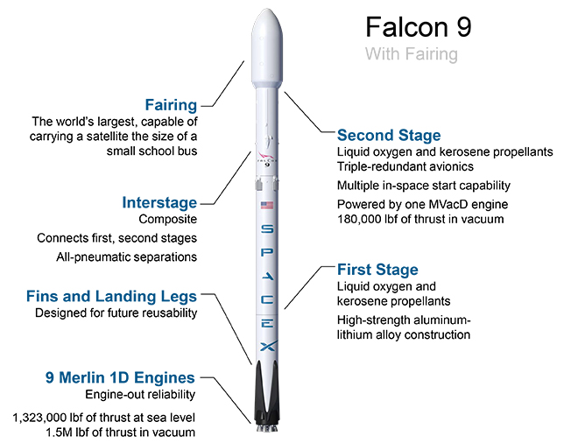



**Stage 1**

The first stage of the Falcon 9 is the bottom most part of the rocket when it is vertical on the launchpad. It stands 41.2 meters tall with a diameter of 3.66 meters and weighs almost 400,000 kilograms or about the weight of a hundred elephants. It is constructed primarily of an aluminum-lithium alloy which is strong enough to withstand the forces required to launch it while also being light enough to take off. These forces are created by the most costly and important part of the vehicle; the 9 Merlin 1D engines which have the power to boost this behemoth upwards. They are fueled by a combination of liquid oxygen and a kerosene propellant stored within the first stage which allows them to burn for 162 seconds. It also holds the landing legs and fins which control it on it’s way back to Earth’s surface. Stage one is the first stage to fire in the staging sequence and has the main purpose of getting the first and second stage, along with the payload, off the ground and started in the right direction. It is located directly below the interstage connector which will be the next important piece of the process.

**Interstage**

The interstage is the part of the rocket that is responsible for connecting the first stage to the second stage. It is 6.5 meters long and is also constructed of the same aluminum-lithium alloy. Within the interstage is the release and separation system which consists of mechanical latches that connect to the two stages as well as a high-pressure helium circuit whose main purpose is to release the latches pneumatically. By doing so the interstage ensures that, once the first stage engine cuts off, the two stages will disconnect from each other and will not make contact after doing so. If the two did hit one another at this point it is likely that the second stage would be damaged or even explode on impact which would almost certainly result in a failed mission.

**Stage 2**

Assuming that the interstage does its job and the first stage is discarded away from the rest of the rocket, it is now the job of the second stage to get the payload to its final destination in space. The second stage uses the same materials and propellant as the first stage but is much smaller. The diameter is the same but it is only about a third of the length at 13.8 meters and a fourth of the mass. It also only has a single Merlin 1D Vac engine which is designed to be more efficient in the vacuum of space and therefore can burn for a total of 397 seconds. Prior to the interstage disconnecting, the engine of the second stage is resting within the the interstage and connected to the interstage by the mechanical latches. On top of the second stage is the payload which can be one of two things depending on what the rocket is transporting. If Falcon 9 is transporting cargo, or humans in the future, the Dragon spacecraft is attached to the top. Otherwise, a satellite and a fairing, which is a protective covering for the satellite, is used.

**Satellite and Fairing**

In the case of a satellite, a 13.1 meter tall composite fairing is attached to the top of the second stage which houses the satellite. The fairing tapers into a point which allows the rocket to be more aerodynamic and is constructed of aluminum and carbon fiber which means it doesn’t add much to the total mass. While the rocket is traveling through the atmosphere at ultrasonic speeds, a lot of heat is created due to drag which would damage or destroy the satellite altogether. For this reason, the fairing covers the satellite until after the first and second stages have boosted the rocket through the atmosphere. Then the fairing is ejected away from the satellite in a similar way to how the first and second stages are separated - pneumatically using a high-pressure helium circuit.

**The Dragon Spacecraft**

The second option is to use the Dragon spacecraft either as a means to transport cargo or a combination of cargo and astronauts. The Dragon has a similar shape to the fairing but stands about half as tall at 7.2 meters. It consists of a pressurized section at the top which is used to store the cargo. There is also a section connected to the bottom known as the trunk which houses cargo that does not need to be pressurized as well as the solar arrays that are needed to power the capsule on its journey. Currently the Dragon is used to transport cargo to the International Space Station but it has the ability to transport humans in the future as well as the cargo needed to keep them alive on longer duration missions.

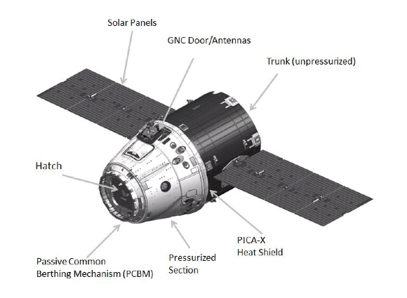

**Launch Procedure**

The standard launch procedure starts with monitoring weather conditions to ensure that the Falcon 9 will have a clear pathway to space. Thirty five minutes prior to takeoff, the rocket propellant and liquid oxygen are loaded into the rocket. When the first stage is ignited, the structure that supports and fuels the rocket pulls away from Falcon 9 and the rocket has liftoff. The first stage burns for approximately two and a half minutes and then the engine is cut off. After a few seconds, the stages separate and the second stage engine begins to burn. Meanwhile, the first stage reignites, flips itself around and burns backwards towards where it launched from. Using the gps location of either the launch pad or a droneship in the water, the Falcon 9 positions itself to land and boosts moments before crashing into the ground in order to execute a soft landing. After the second stage completes its burn to get to the desired altitude, the engine cuts off and the payload separates from the second stage. From here, both the satellites and the Dragon have their own thrusters to finely adjust their final trajectories.

**Impact**

Unlike most other space exploration companies, SpaceX is concerned about making spacecraft viable in the future. Prior to SpaceX, not a single part of rocket was reused which means they were more wasteful and expensive and therefore less feasible of a technology for the future. Due to the careful planning and design of the Falcon 9, other planets such as Mars and beyond are now possibilities for future manned missions.

Bibliography

"Falcon 9." *SpaceX*. N.p., n.d. Web. 18 Sept. 2016. <http://www.spacex.com/falcon9>.

"Falcon 9 V1.1 & F9R – Rockets." *Rockets*. N.p., n.d. Web. 18 Sept. 2016. <<http://spaceflight101.com/spacerockets/falcon-9-v1-1-f9r/>>.

Siceloff, Steven. "Launch Timeline." *NASA*. NASA, 16 July 2016. Web. 18 Sept. 2016. <https://blogs.nasa.gov/spacex/2016/07/16/launch-timeline/>.